1. This is my Web API running.

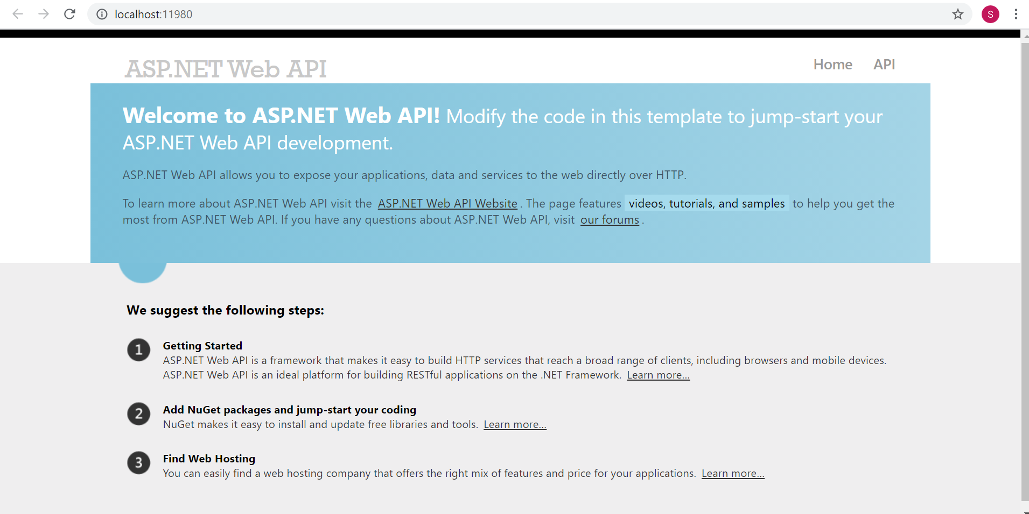

1. This is my MVC UI application running.

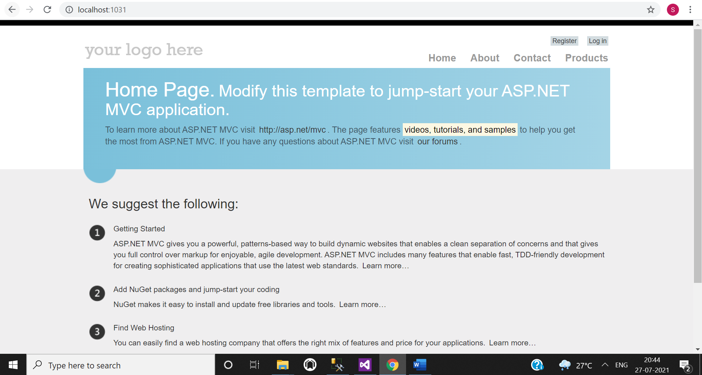

1. I have made this application for inventory management. So there are four menu shown here. Forth one in the products menu. List of products are shown.

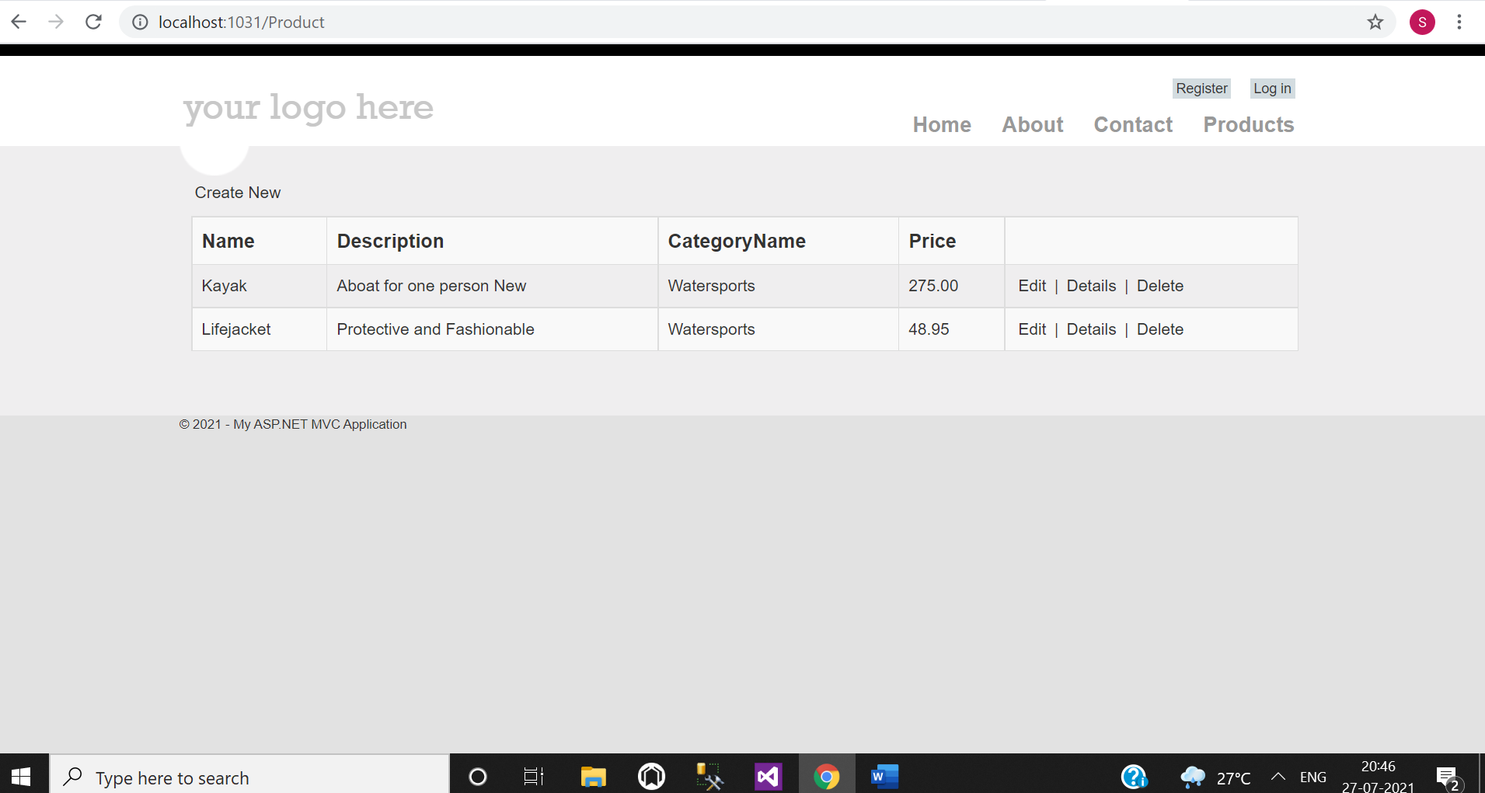

1. Create new product screen with validations.

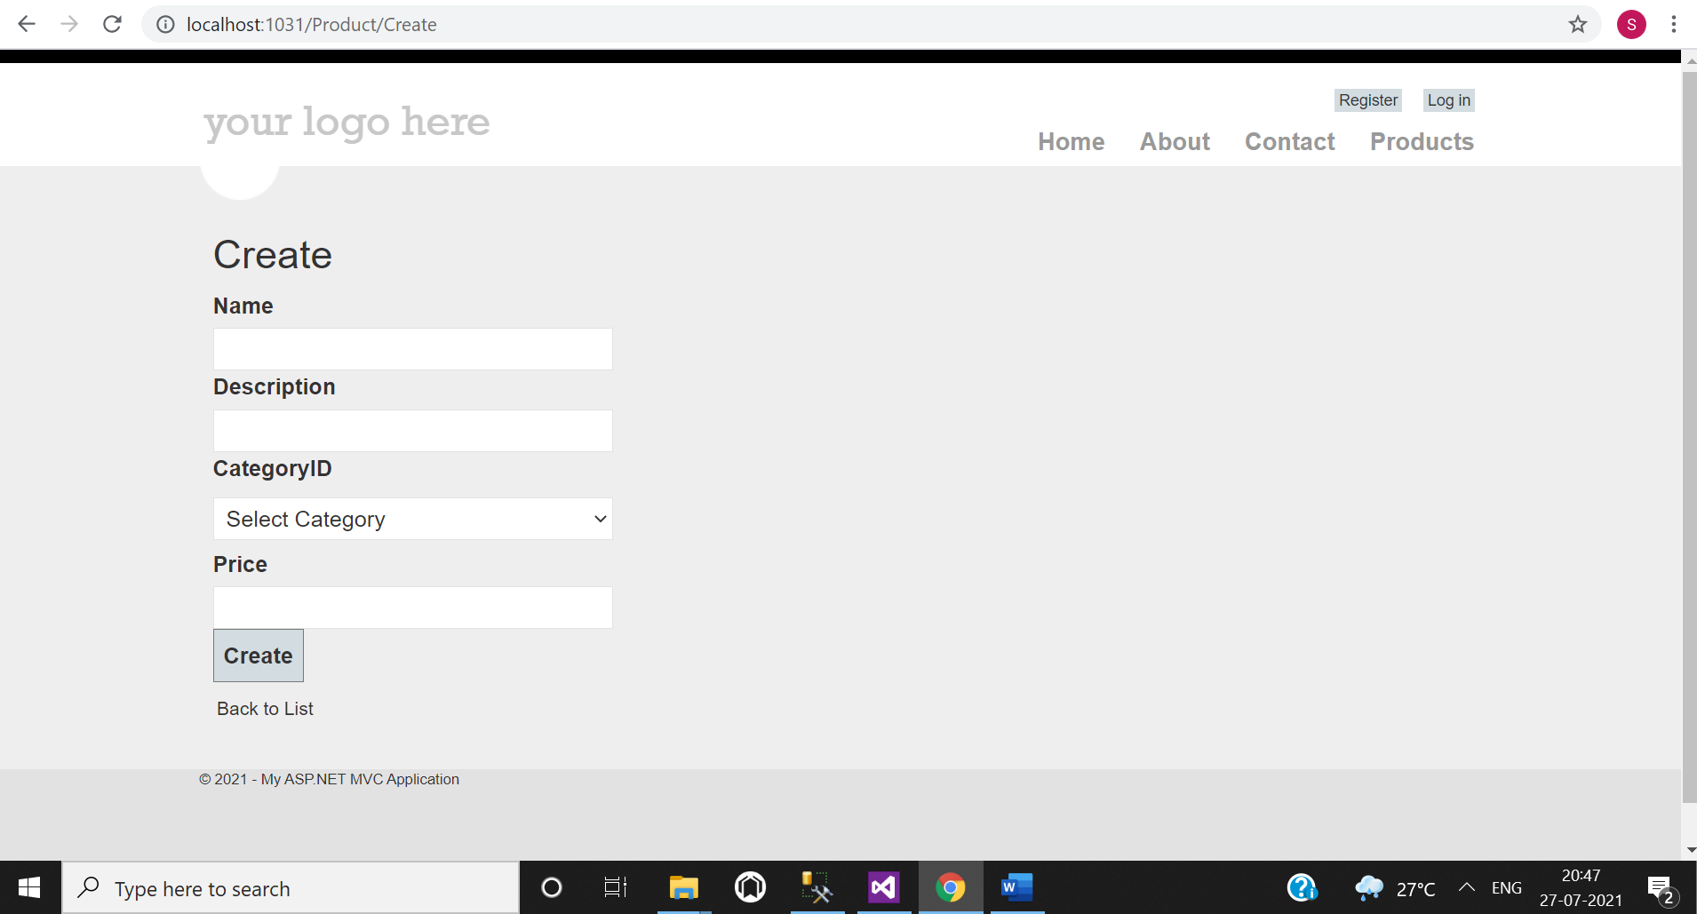

1. Edit existing product with all validations.

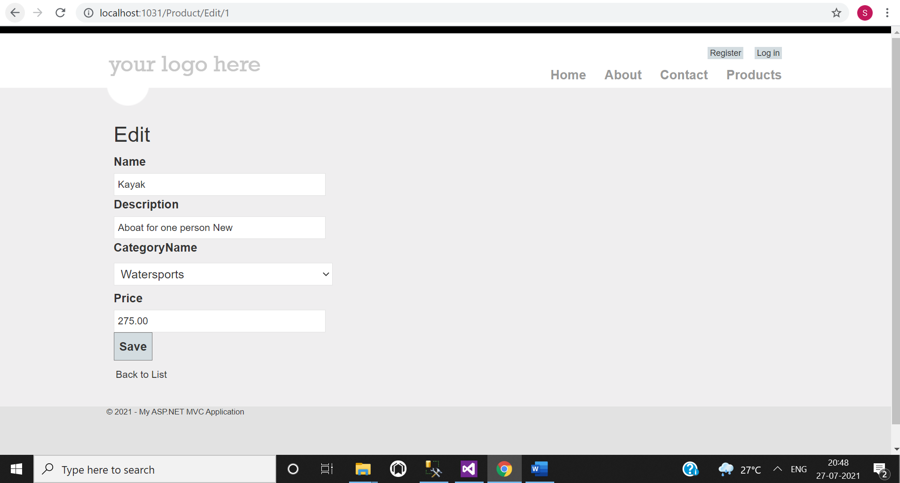

1. See details of products.

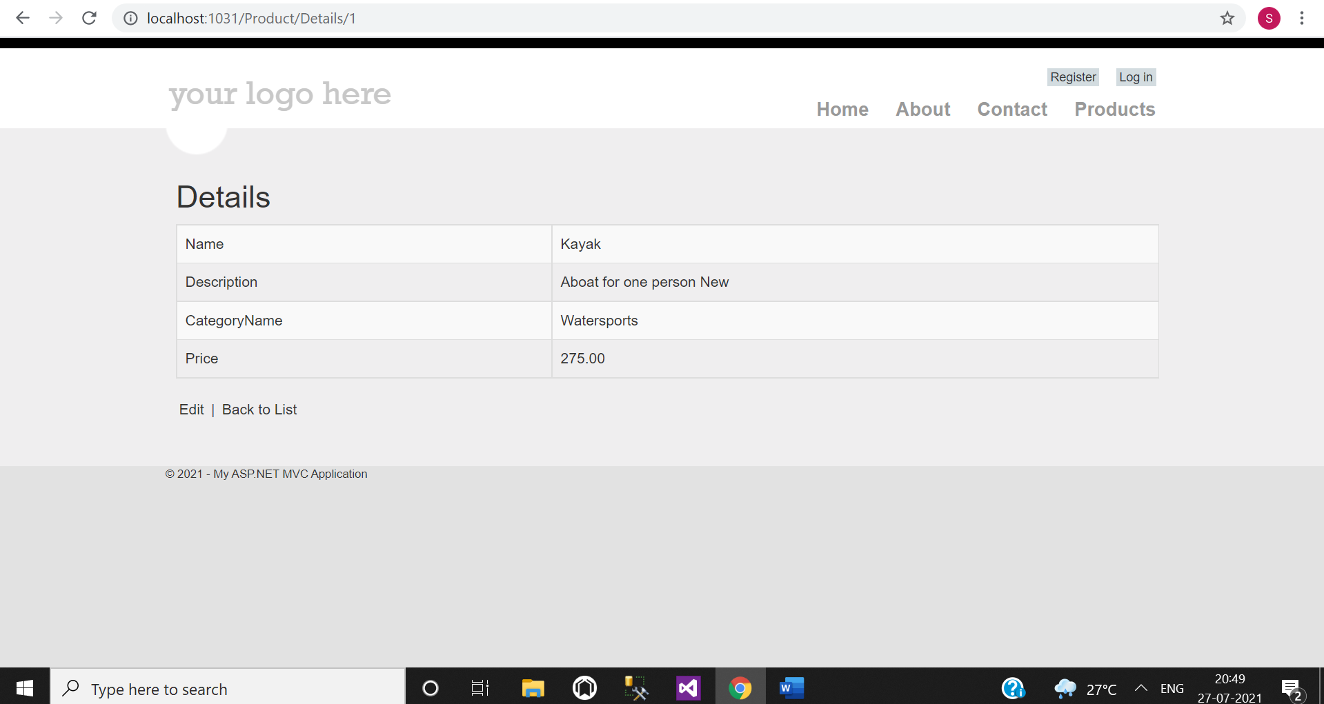

1. Delete existing products.

